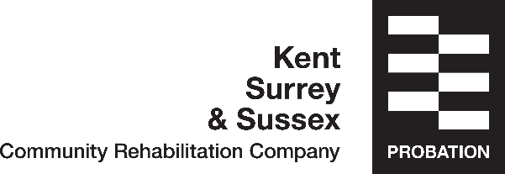

Debt Advice Fact Sheet

This fact sheet may be of help if you are experiencing debt issues

Priority debts you should pay off first

These aren’t necessarily the largest debts or the debts with the highest interest rate. But if you don’t pay them, you could end up:

- Losing your home – because you’re not keeping up mortgage or rent payments
- Being made bankrupt – because you’ve haven’t paid your tax bills
- Having your heating or lighting cut off – because you haven’t paid your fuel bills
- Receiving a court summons

Priority Debts include:

- Income Tax, National Insurance and VAT
- Mortgage, rent and any loans secured against your home
- Council Tax
- Gas and electricity bills
- Child maintenance
- TV license
- Hire purchase agreements, if what you’re buying with them is essential
- Court fines

Your non-priority debts include:

- Credit card, store card debts or payday loans
- Catalogue, home credit or in-store credit debts
- Overdrafts
- Bank or building society loans
- Personal loans
- Money borrowed from friends or family

Target the most expensive non-priority debt first. If you can afford to pay more than the minimum payments on your non-priority debts, there is a general rule about which one to overpay first, or next. Target the debt with the highest interest rate shown on your monthly statement or loan agreement first. Pay as much as you can afford without breaking the terms of other credit agreements you have. However, check that you won’t be charged any penalty or default charges for overpaying.

For Debt advice the following charities offer free impartial advice over the telephone:

Step Change Charity
www.stepchange.org
0800 138 1111
StepChange helps change the lives of thousands of people every week. Their expert advice is impartial and personalised to each individual situation.

National Debtline
www.nationaldebtline.org
0808 808 4000
National Debtline has helped millions of people with their debts. They'll talk you through options and give clear advice on how to take back control.

PayPlan
0800280 2816
www.payplan.com
PayPlan provides the debt advice and support to enable you to take charge of your finances.

Debt Counsellors Charitable Trust
03004562726
www.debtc.org
A telephone debt advice service for people living in England and Wales

Debt Advice Foundation
www.debtadvicefoundation.org
0800 622 6151
Debt Advice Foundation is a national debt advice and education charity offering free, confidential support and advice to anyone worried about debt

Business Debt Line
0800 197 6026Debt advice for anyone who owns their own business

