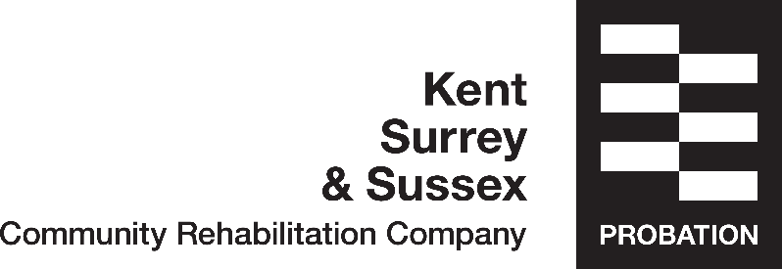

Mentor Fact Sheet

Have you thought about having a mentor?

KSS CRC run a mentor scheme for service users leaving custody. Mentors are people from the local community who volunteer their time to service users to help with practical day to day issues as they resettle into the community.

A mentor works on two levels, both supporting the mentee with day to day issues and supporting them as they take steps to a life away from crime.

The type of support could include:
Accompanying service users to appointments such as Job Centre, local council, Housing Providers and GP.
Providing advice on dealing with a multitude of issues encountered, such managing bills, tenancy, healthcare and diet.
Help with reading documents.
Going out for a coffee and a chat
Providing Encouragement and support when you need it.

If you think that you would be interested in having the support of a mentor please let the Resettlement team/ or a Resettlement Redband know and we will arrange for someone to come and talk to you more about it.

